- Title of the Project :Smart Streetlight detection using LDR and IR Sensor

- Name of the Guide : Mr Soumen Das

Ph.D(Reg)*vM.Tech.MCA M.Sc. MBA B-Tech

- Educational Qualification of theGuide(s)
Y

- Working / Teaching experience of the Guide:Mr Soumen Das ( 3 Years)

- Software used in theProject

  - ESP 8266
  - MsOffice

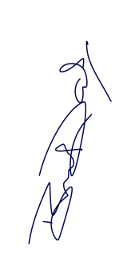

Signature of the Guide

For Office Use Only

Approved
Not Approved

……………………………………………. Signature, Designation Stampofthe Project Proposal Evaluator
Date: …………………….

Self Certificate

This is to certify that the dissertation/project proposal entitled “Smart Streetlight detection using LDR and IR Sensor” is done by Anima Samanta an authentic work carried out for the partial fulfilment of the requirements for the award of the degree of Diploma In Electronics & Tele-Communications under the guidance of Soumen Das. The matter embodied in this project work has not been submitted earlier for award of any degree to the best of my knowledge and belief.

Name of the Student(s): Anima Samanta Signature of the Student:
Subhadeep Karmakar
Tithi Mondal
Subhajit Majhi,
Sandipan Saha,
Suman sing,
Krishnadas Roy,
Robin Deshmukh,
Rabin Kumar Das,
Tanish Khan,
Subham Mandal,
Supratick Murmu,
Souvik Charan,
Rohan Bhakat,
Bristi Dey,
Anima Samanta,
Omprakash Roy,
Arun Saren,
Ayan Dutta,
Debanjan Ghosh,
Debraj Goswami,

Certificate By Guide

This is to certify that this project entitled “Smart Streetlight detection using LDR and IR Sensor”submitted in partial fulfilment of the degree of Diploma in Electronics and Telecommunication Engineeringby KG Engineering Institute, Bishnupur through, Bengal college of engineering and technology done by Anima Samanta

Is an authentic work carried out under my guidance & best of our knowledge and belief.

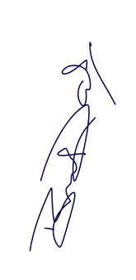

Signature of the student Signature of theGuide

Date: Date:

Certificate of Approval

This is to certify that this documentation of Summer Industrial Training Program 2017, entitled

“Smart Streetlight detection using LDR and IR Sensor” is a record of bona-fide work, carried out by Subhadeep Karmakar, Tithi Mondal,Subhajit Majhi, Sandipan Saha, Suman sing, Krishnadas Roy, Robin Deshmukh, Rabin Kumar Das,Tanish Khan, Subham Mandal, Supratick Murmu, Souvik Charan, Rohan Bhakat, Bristi Dey, Anima Samanta, Omprakash Roy, Arun Saren, Ayan Dutta, Debanjan Ghosh, Debraj Goswami,for your shipment Zice with tracking id FMPC2531013088. Please share with Wishmaster for delivery of the shipment.Ekartnder my supervision and guidance.
In my opinion, the report in its present form is in fulfilment of all the requirements, as specified by the Maulana Abul Kalam Azad University of Technology and as per regulations of the Ardent Computech Pvt Ltd. In fact, it has attained the standard, necessary for submission. To the best of my knowledge, the results embodied in this report, are original in nature and worthy of in corporation in the present version of the report for Diploma in Electronics and Telecommunication Engineering.



Soumen Das
Technical Trainer
Ardent ComputechPvt Ltd
(An ISO 9001:2015 Certified)
(Approved by NCVT & Ministry of HRD, Govt of India)

